How to Enable Cookies in your Browser:
(Source: http://www.wikihow.com/Enable-Cookies-in-Your-Internet-Web-Browser )
Google Chrome 10.x (PC):
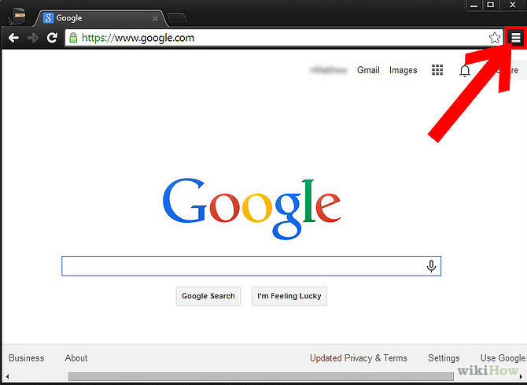
- Click the "customize and control" menu at the top right.
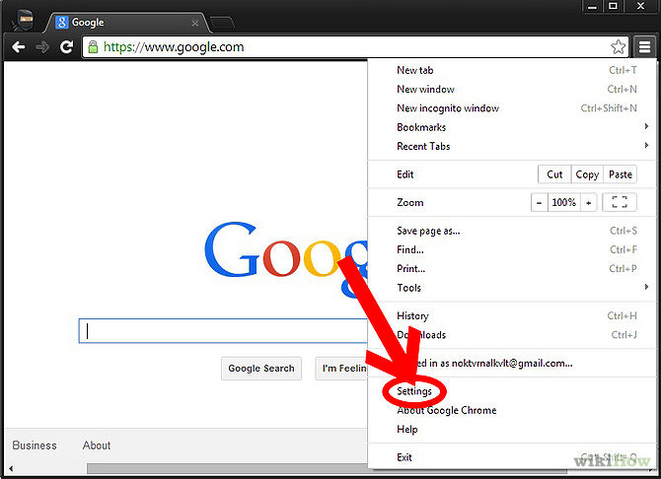
- Click the "Settings" controls. A new tab will automatically open.
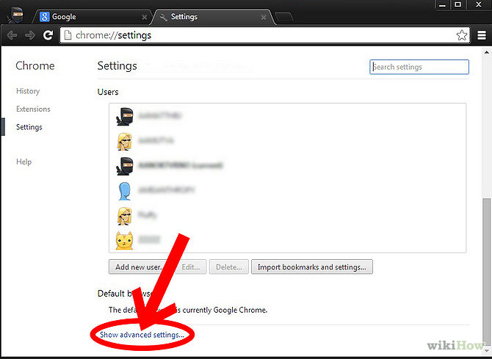
- Click on "Show advanced settings...." near the bottom of the page.
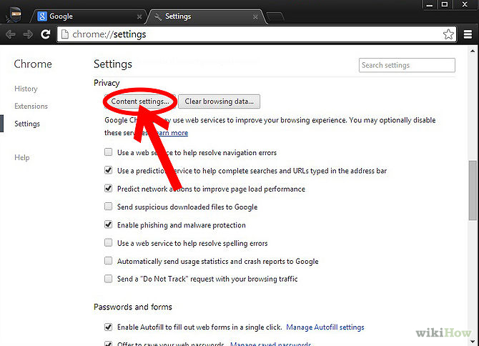
- Click on "Content settings...."
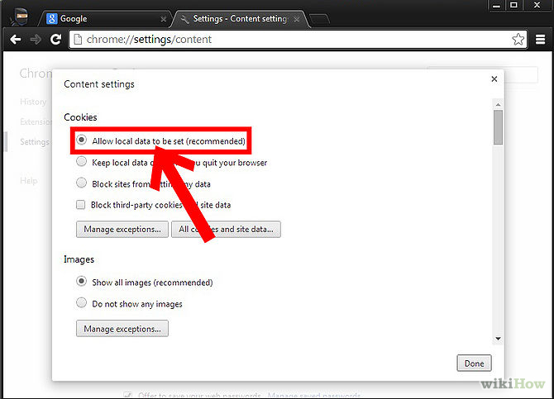
- Under "Cookies," make sure that "Allow local data to be set (recommended)" is selected.
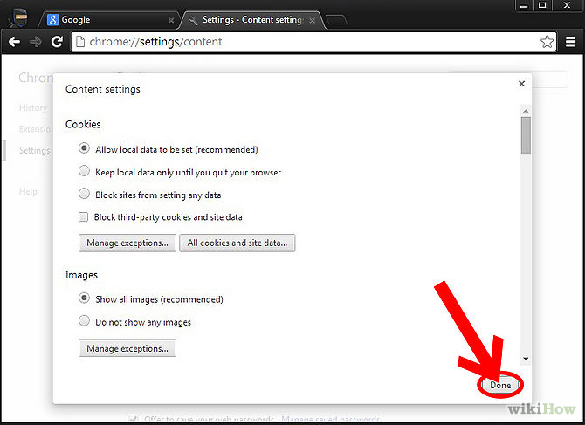
- Click "Done."
________________________________________________________________________

Google Chrome 10.x (Mac):
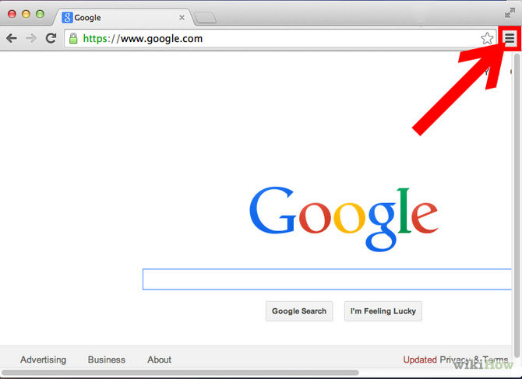
- Click the Chrome menu
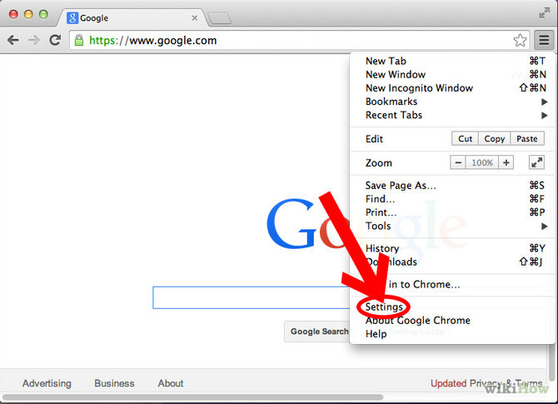
- Select Settings.
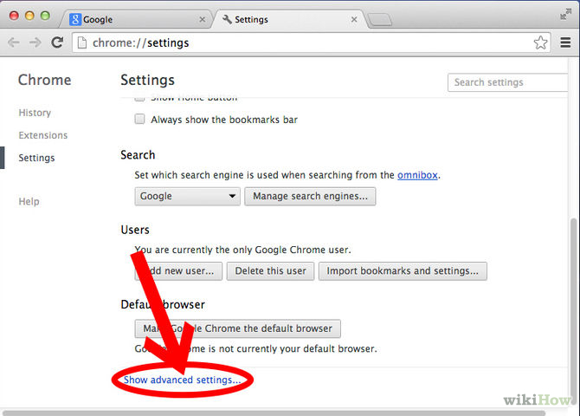
- Click on "Show advanced settings...." near the bottom of the page.
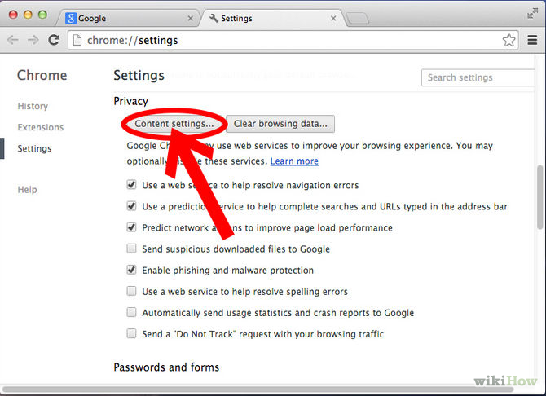
- Click Content Settings
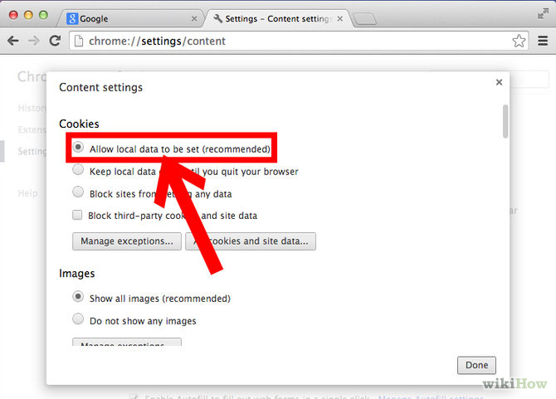
- Click 'Allow local data to be set'
________________________________________________________________________

Mozilla Firefox:
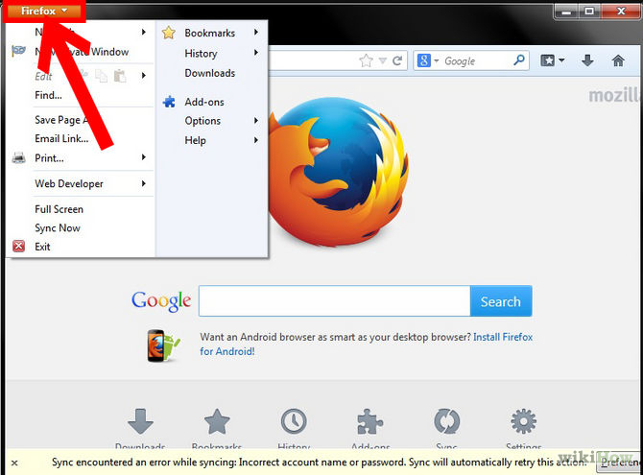
- Click the Firefox menu up top left. (On a Mac, click the Firefox menu.)
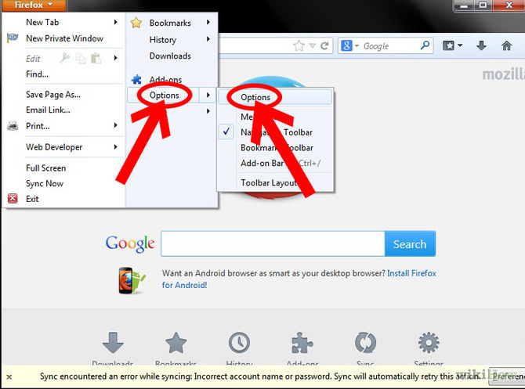
- Select "Options", and then "Options" again. (On a Mac, select Preferences.)
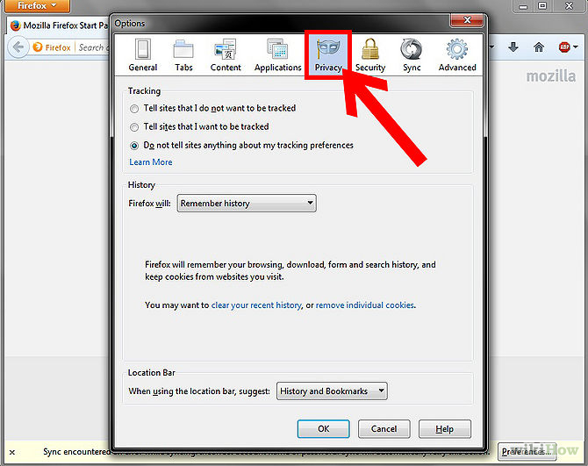
- Click the Privacy tab.
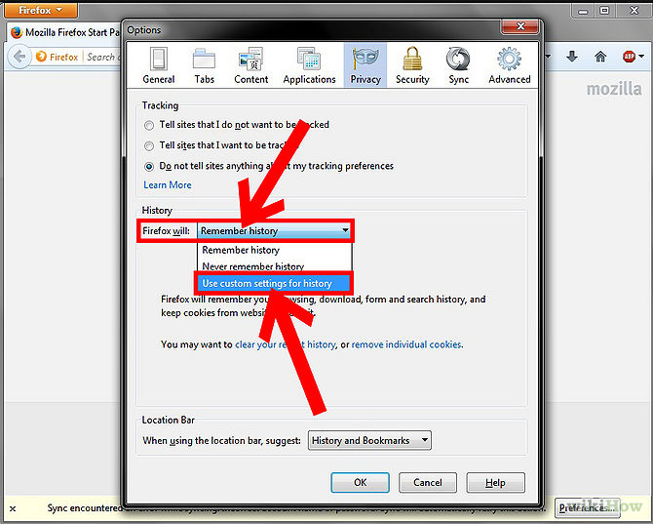
- Click the "Firefox will..." dropdown and select "use custom settings for history".
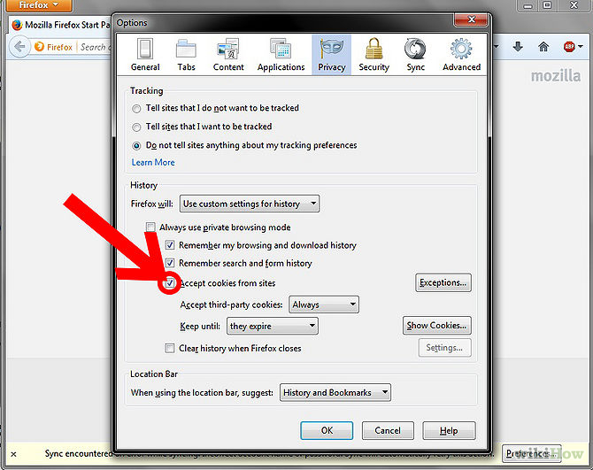
- Select the "Accept cookies from sites" checkbox.
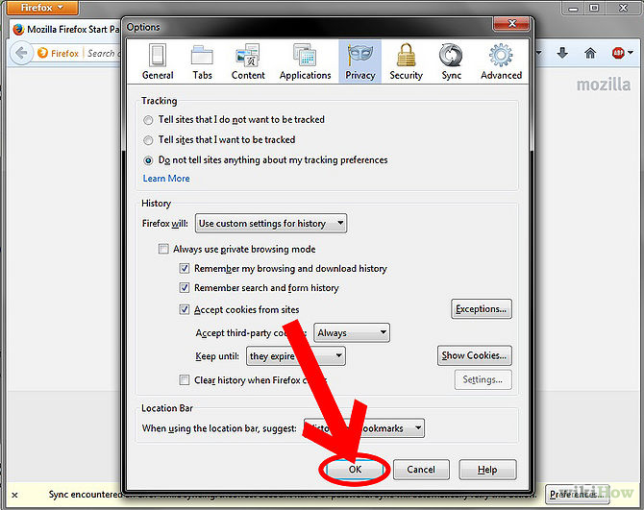
- Click the OK button.
________________________________________________________________________

Internet Explorer:
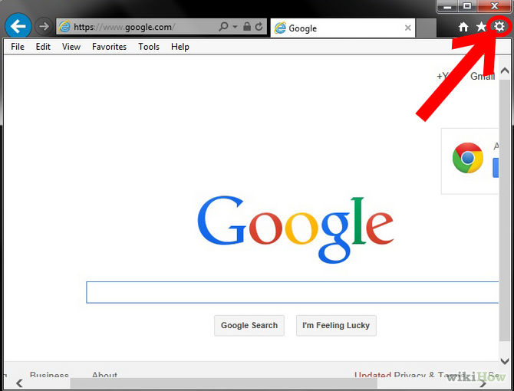
- Click the Tools menu top right. It will look like a gear icon.
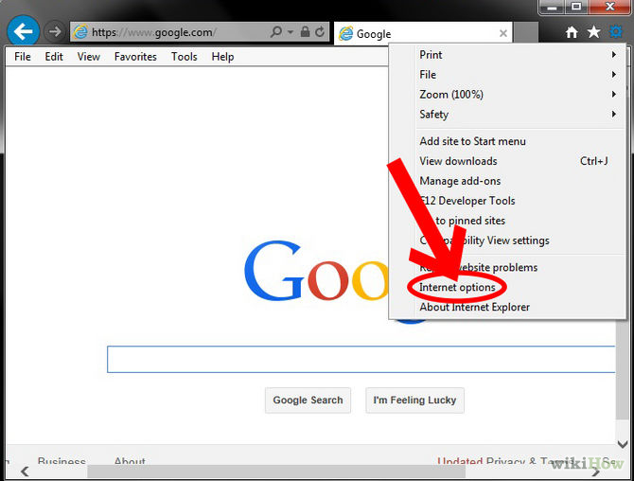
- Select "Internet Options."
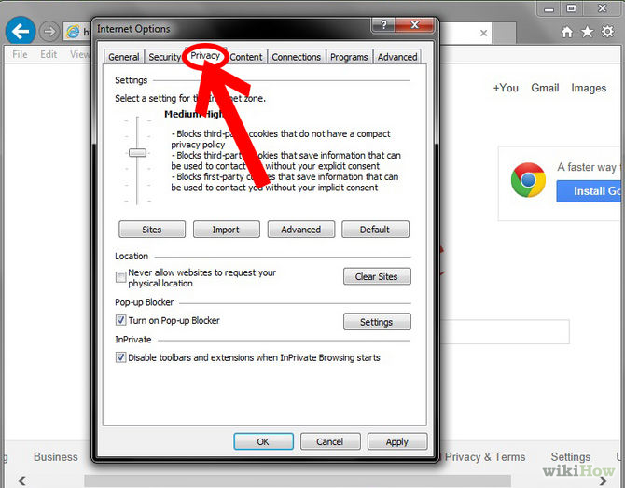
- Click the Privacy tab.
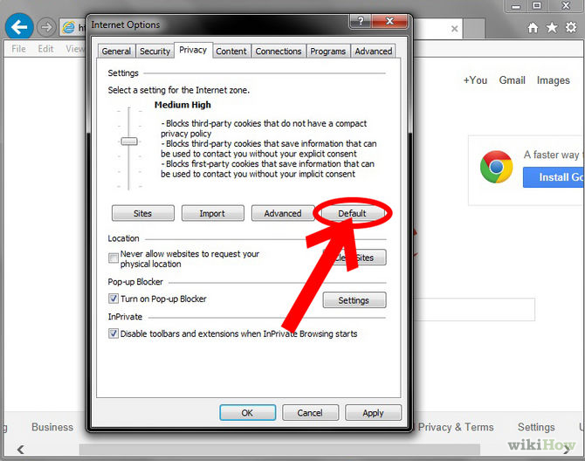
- Click the "Default" button (or manually slide the bar down to 'Medium').
If you want to manually adjust your options, click the "Advanced" button to the left of "Default". This will give you more options for customization.
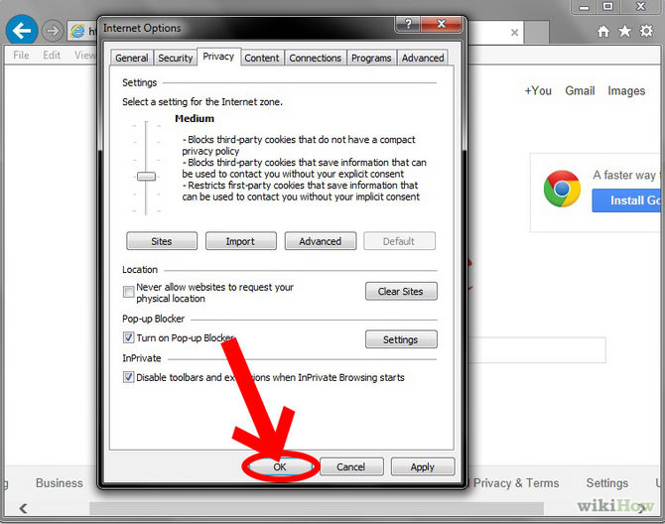
- Click the "OK" button.
________________________________________________________________________

Apple Safari (Mac):
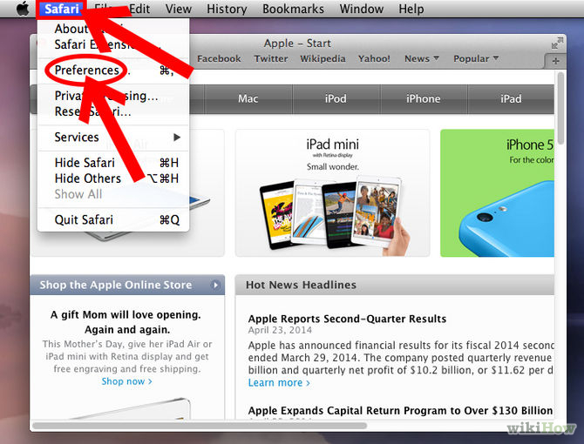
- Click the "Safari" dropdown in the top left of your screen and select "Preferences"
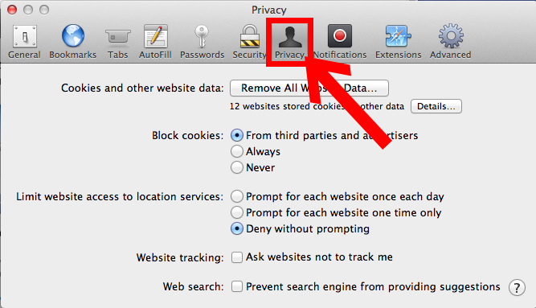
- Click the Privacy tab.
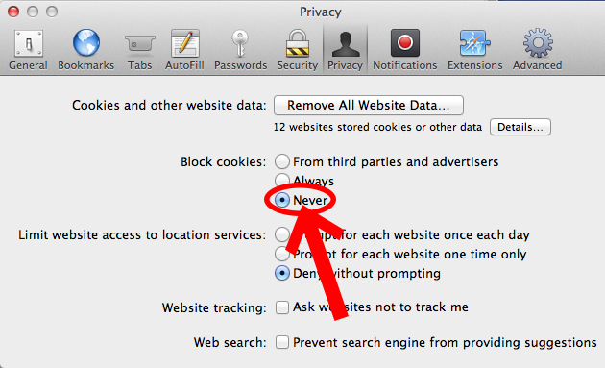
- In the "Block Cookies" section, select "Never."

________________________________________________________________________

Apple Safari (iPhone, iPad, iPod Touch):

- Go to the settings app
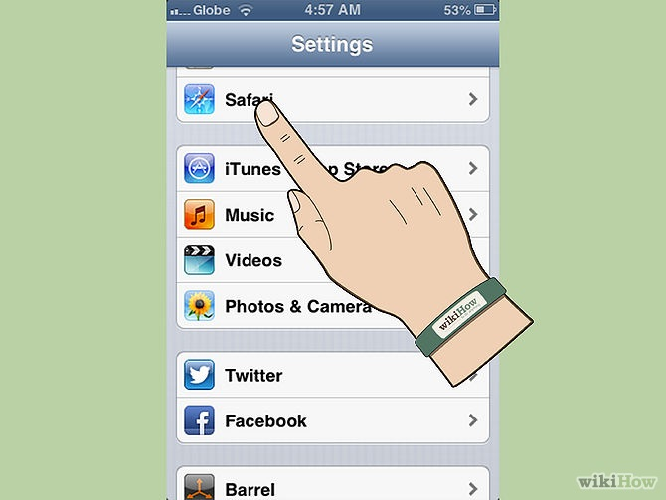
- Go to the category called safari
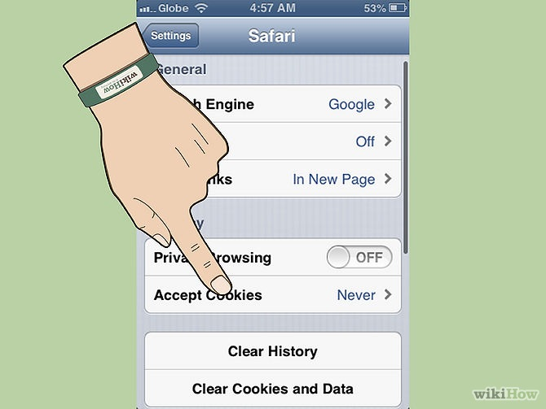
- Go to the part that says accept cookies___________ from whatever your settings are. Default is never.
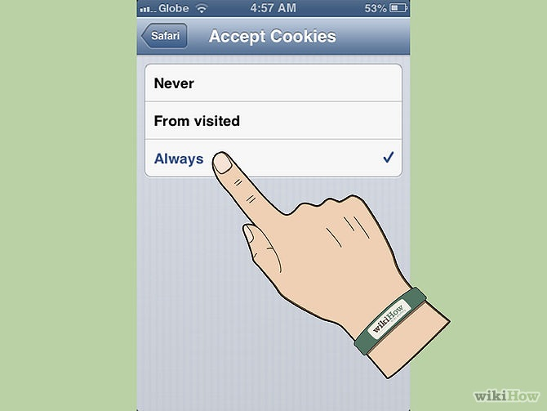
- Pick what you want, always, from visited or never
________________________________________________________________________

Opera:
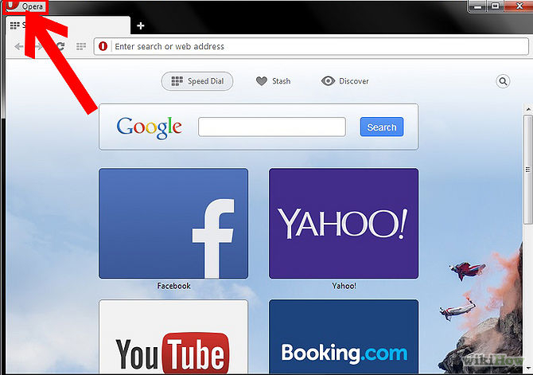
- Click on the "Opera" menu at the top left of the browser.
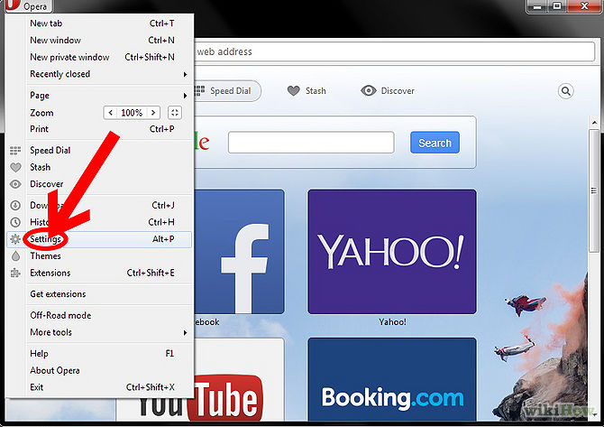
- Select "Settings"
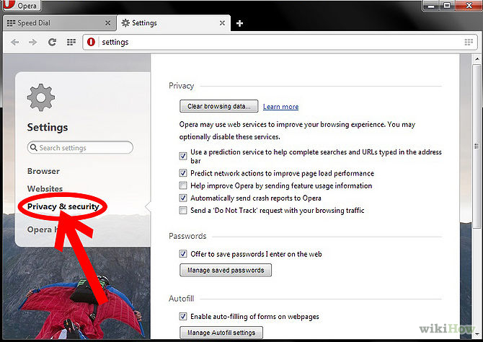
- Choose the "Private and Security" tab.
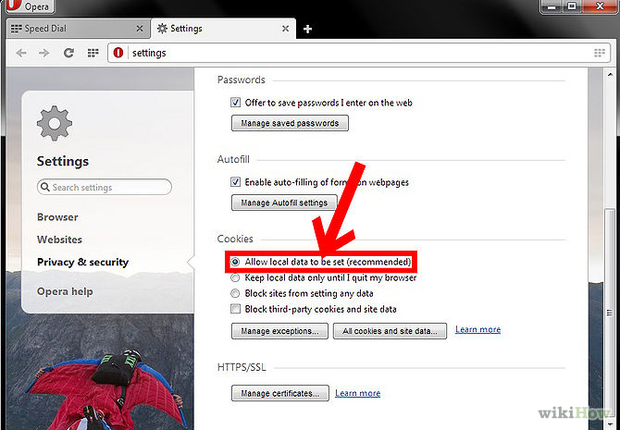
- Under "Cookies," make sure that "Allow local data to be set (recommended)" is selected.
________________________________________________________________________

Netscape Navigator:
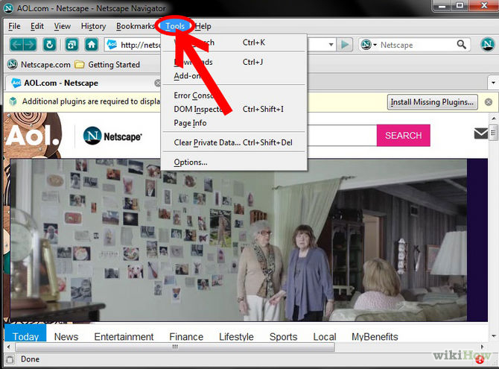
- Select "Tools" from the top menu.
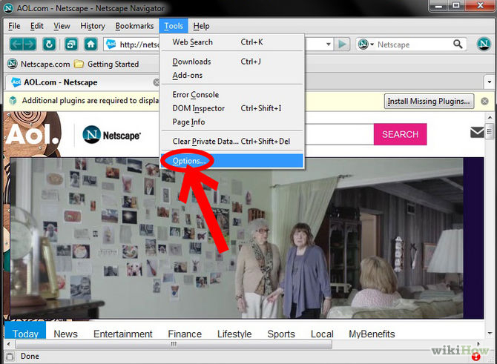
- Choose "Option".
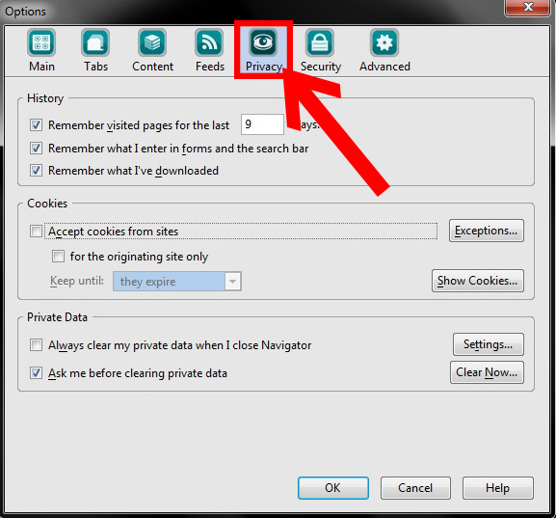
- Choose "Privacy".
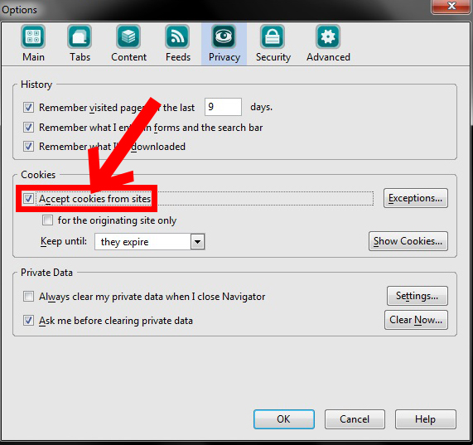
- Check "Accept Cookies from site" and click OK.

